how good is your correlation?
Graphs don't always fit neatly on a straight line. Sometimes points can be scattered all over the place but still show an overall trend. We use a number of tests (which you may learn about in Maths) to describe how closely the points lie to a line when we draw it (we call this linear regression). The closer on average the points are to the line, the stronger the association between the variables. Can you find any correlations between the Outbreak variables and the national school illness data? How good is the correlation?

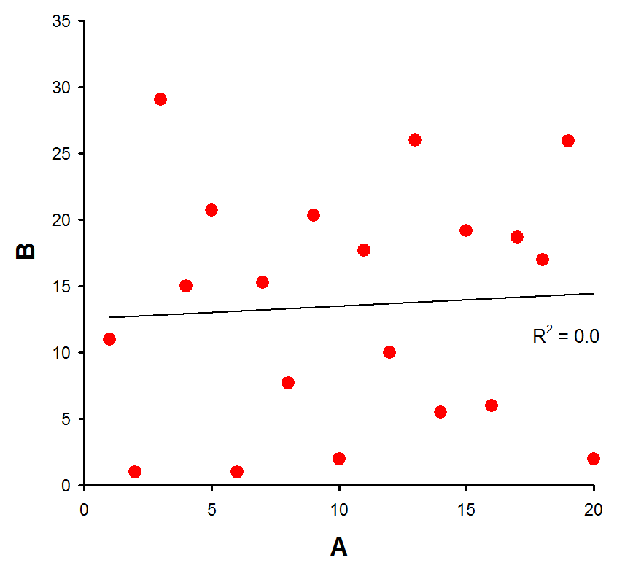  no correlation  the two sets of data aren't related | 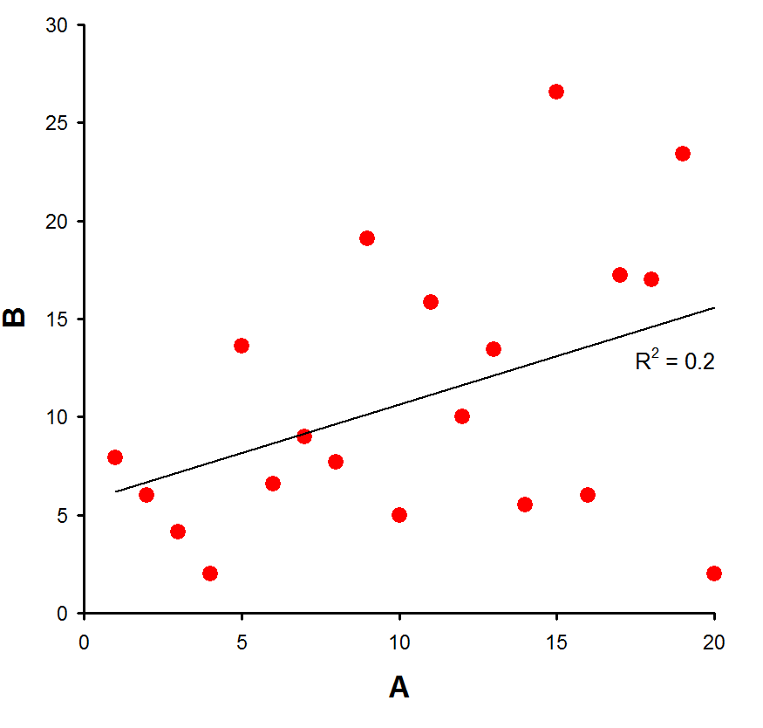  weak correlation  there is some evidence to suggest that A is linked to B | 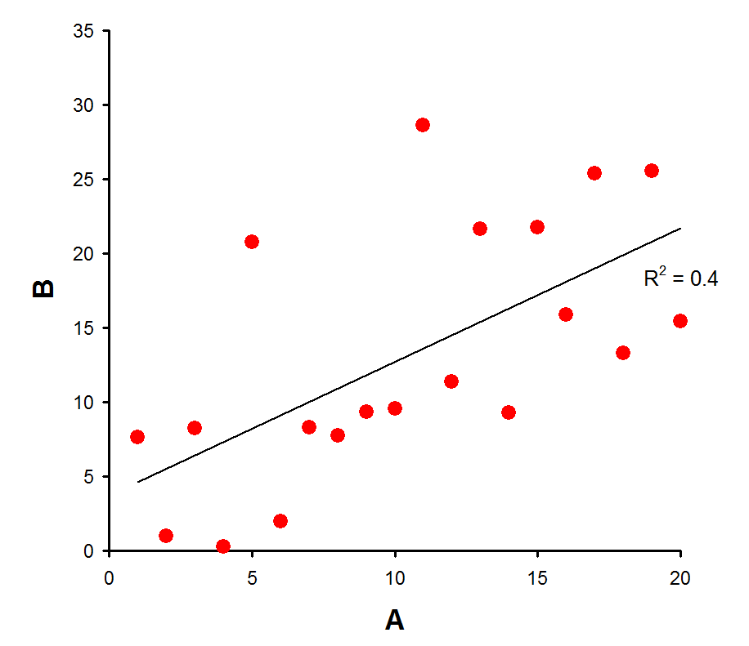  medium correlation  there is good evidence that A and B are related
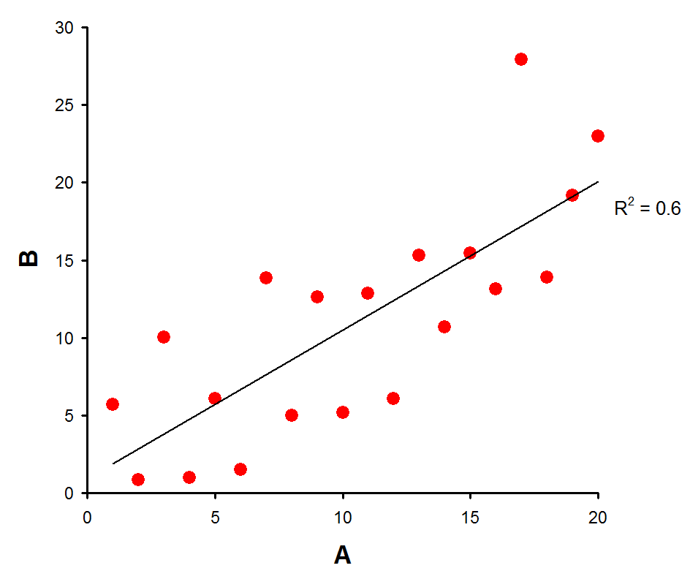  strong correlation  A and B appear to be closely related. As A increases, so does B | 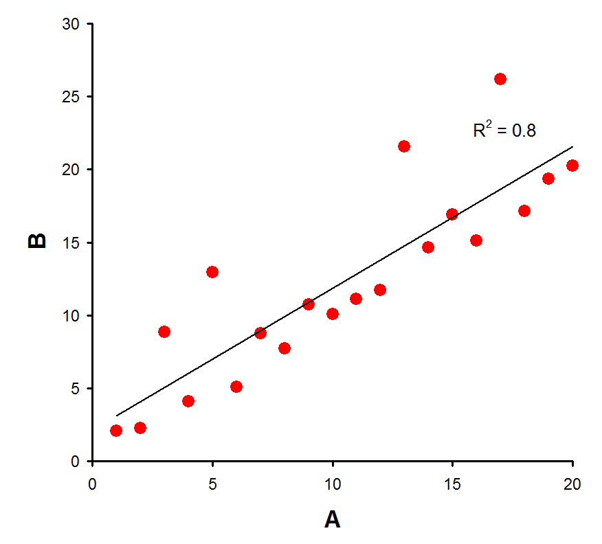  very strong correlation  there is a very strong connection between A and B. | 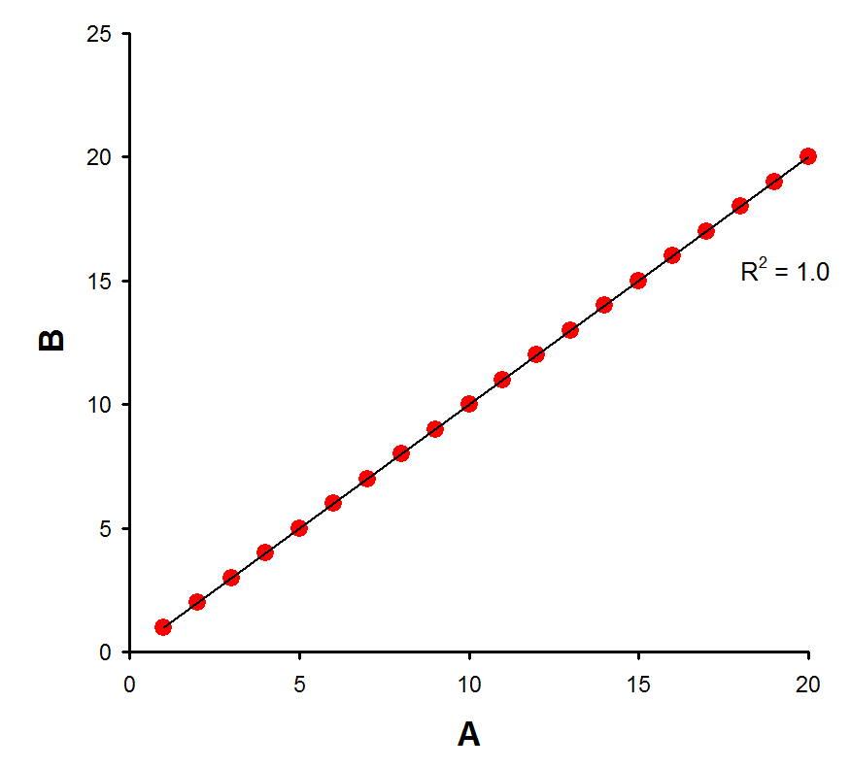  perfect correlation  all the dots fit exactly on the line

