Describing and explaining patterns
This is a graph but there's no axis labelled to describe the dependent variable. Look carefully at the data. Look at recurring patterns and overall trends. What sort of thing could behave like this? (we'll give you a clue .. the fact that holidays and similar dates have been labelled suggests it's something that humans do!)

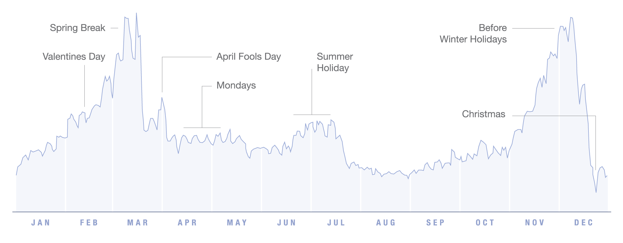
Any ideas?
In a few minutes your teacher will tell you what this graph represents. Once you know, can you explain why the data might behave the way it does? It doesn't matter if you are wrong - it's likely that we don't fully understand enough ourselves to know if you're right or wrong!

Why might there be a drop in the data before valentines day and after it?
Why might there be a peak in data on Mondays?
Why might the data remain low in August? What happens to the Monday pattern in this time and why?
What reasons might there be for the drop in the lead up to and on Christmas day?

This graph has been edited from one available at informationisbeautiful.net and is by David McCandless & Lee Byron

