Decipher my Data! The Race to Publication

PUBLISHED!  Copies of Dr Rob’s paper are being read all over the world! | Oops!  Another scientist who is working in the same area as you publishes work that shows the same thing you found out before your paper was published. Now people will not think your work is as original and worthy of publication.  Move back 15 places  80 |  |  |  | 60 | 59 | 58 | 57 | 56
49 | 50 | 51 | 52 | 53 | 54 | Nice one!  Your journal decides to run a “pre-print” which means scientists can access your work sooner online instead of having to wait for the paper edition to be printed. Lots get in contact with you to talk about your work.  Move forward 4 places
48 | 47 | 46 | Nice one!  Experts in your field known as reviewers (or referees) read your paper and say it's ready to be published as it is.  Move forward 4 places |  |  | 44 | 43 | 42 | 41
31 | 32 | 33 | 34 | 35 | 36 | 37 | 38 | 39 | Credibility!  Add two onto every roll from now on!
30 | Oops!  Experts in your field known as reviewers (or referees) read your paper and find major flaws in your work. They don't think it's valid because you did not take account of all the variables. In order to be published – other experts have to check your paper to see if they agree with your findings – this is called “peer review”  Move back 10 places  45 |  |  |  |  | Nice one!  you speak at a seminar (visiting another university to tell scientists there). Some of these scientists use your ideas to help them in their work and the questions they ask you help you to think of areas you'd like to look at further in your own work.  Move forward 4 places  42
Nice one!  you speak at a seminar (visiting another university to tell scientists there). Some of these scientists use your ideas to help them in their work and the questions they ask you help you to think of areas you'd like to look at further in your own work.  Move forward 4 places  36 |  |  |  | 25 | 26 | Oops!  experts in your field known as reviewers (or referees) read your paper and say you need to go back and collect more data before it's ready to be printed. In order to be published – other experts have to check your paper to see if they agree with your findings – this is called “peer review”  Move back 6 places
23 | Nice one!  The editor at the Lancet likes your paper, they think its findings are original (no-one has found this out before) and valid (everything has been done correctly)  Move forward 6 places |  |  | Oops!  the editor of your first choice of journal doesn't think your paper shows findings that are very surprising. This means that her readers might not find your paper that interesting to read. Just like any magazine, in order to be published, you have to be worth reading!  Move back 6 places  28 |  |  |  | 20 | 19
11 | 12 | 13 | 14 | 15 | 16 | Nice one!  You speak at a conference, telling others about your work. Lots of scientists will get to hear about what you've done.  Move forward 3 places |  |  | 18
10 | Credibility!  Add two onto every roll from now on! | 8 | Oops!  You choose to publish in "the journal of Materials Research" they are not likely to be interested in your paper because they specialise in another area. There are so many journals that scientists use to publish their research, it’s important you choose the right one.  Move back 8 places |  |  |  | Nice one!  You speak at a conference, telling others about your work. Lots of scientists will get to hear about what you've done.  Move forward 3 places
Start  Can you help Dr Rob get his research published? | 2 | Nice one!  You choose to publish in "the Lancet" this is a journal that specialises in your area and has high “impact” so lots of scientists will read your findings but you are in competition with a LOT of other scientists to get your work published. It could be hard going! Good luck!  Move forward 3 places |  |  |  |  | Credibility!  Add two onto every roll from now on! | 4 | 5

Can you help Dr Rob get his work published?

Getting your work published as a scientist means that other people can read about what you’ve done but it’s not as simple as writing a piece of work at school. Your work has to be
- original (no-one has done it before),
- valid (you haven’t made any mistakes in the way you did your experiment)
- interesting and relevant (it has to be right for the publication and it needs to be worthy of reading – there’s no point writing about your new research proving dogs can’t live on the Sun!)

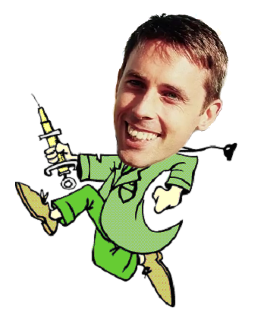
As you try to get to the top of the board to get your work published – think about what things held you up and what things pushed you on. You should be able to name at least one of each and explain why it was a good or bad thing.

You will need:
A die
A counter to represent you

Rules:
Roll the die to move in turns.
The first to publish wins.
Credibility
Scientists with more credibility are trusted more by other scientists. They get this by having a proven track record of good quality research. You can earn more credibility by landing on a credibility square. Add 2 onto every roll of the die for the rest of the game. Each person can only collect credibility once. If you land on a credibility square and you already have credibility, treat it like a normal square!

